**Microsoft Access: Maintenance Database**

**Task 1**

Use the main menu to add a new machine in the system.

**New machine data:**

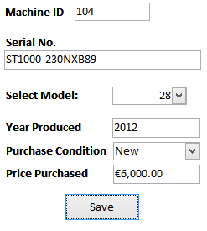

**Task 2**

Use the main menu to start a new procedure in the system.

**Procedure data**

|  |  |
| --- | --- |
| **Select Machine** | ST 1000/Solar Trak |
| **Procedure Description** | Sensor replacement (solar tracker) |
| **DateDue** | *Select today’s date* |

**Data on operations and operators**

|  |  |
| --- | --- |
| **Operations** | **Operators** |
| Solar power off | Tine Kovačič |
| Solar sensor change | Janez Novak |
| Solar power on | Tine Kovačič |
| Solar parameter test | Janez Novak |
| Solar start | Janez Novak |

**Task 3**

Use the main menu to search and complete the previous procedure.

**Data on Procedure:** (Select the latest procedure added in the system)

|  |  |  |  |
| --- | --- | --- | --- |
| **Date on Operations** | **Start Time** | **End Time** | **Date Completed** |
| Solar power off | 8:00 | 8:03 | *Today* |
| Solar sensor change | 8:04 | 8:07 | *Today* |
| Solar power on | 8:08 | 8:11 | *Today* |
| Solar parameter test | 8:12 | 8:22 | *Today* |
| Solar start | 8:23 | 8:27 | *Today* |

**Task 4**

Create a query that requests the user to enter POSITION for an operator, and then displays all the operators who work in this position.

**Task 5**

Create a query that displays the main details of the table “Maintenance_Log” and also the duration (in minutes) of each operation.

**The required fields are:**

* OperatorID (Maintenance_Log_Table)
* FirstName (Operator_Table)
* LastName (Operator_Table)
* OperationID (Maintenance_Log_Table)
* OperationName (Operation_Table)
* StartTime (Maintenance_Log_Table)
* EndTime (Maintenance_Log_Table)

In addition, the column “duration” must be generated by the query.